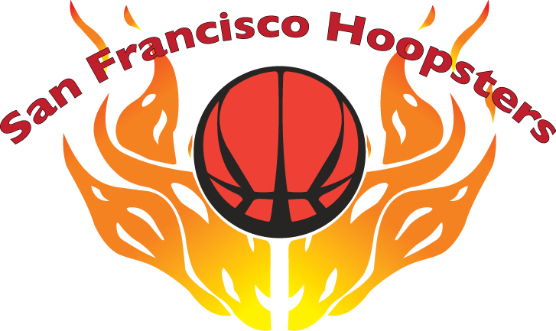

16th Annual Invitational Basketball Tournament
June 13-14, 2020

ROSTER FORM

ORGANIZATION:

TEAM NAME:

DIVISION: 10th 7th

COACH:

CONTACT PERSON:

ADDRESS:

TELEPHONE:

E-MAIL:

Please fill out roster in numerical order by jersey numbers. Roster changes must be received by May 1, 2020 and are subject to approval at the discretion of the tournament committee.

 | NAME OF PLAYER | JERSEY # | HEIGHT  (ft-in) | GRADE | BIRTHDATE  (mm/dd/yy)
1
2
3
4
5
6
7
8
9
10
Awards are limited to 10 players per team.

Roster forms are due by March 31, 2020.
Please send completed roster and check payable to “SF Hoopsters Organization” to:
Stephen Chan
50 Victoria Avenue, Suite 220
Millbrae, CA 94030

