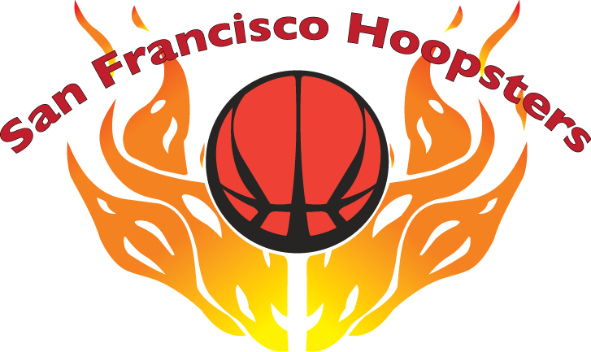

15th Annual Invitational Basketball Tournament

June 8-9, 2019

PLAYER MEDICAL & LIABILITY RELEASE/

CONCUSSION UNDERSTANDING AGREEMENT FORM

It is clearly understood by the undersigned applicants and their parent(s) and/or legal guardian(s) that the San Francisco Hoopsters Organization, Tournament Officials, Coaches and Volunteers, and Tournament/Jamboree Location shall not be liable for any injury or loss sustained by the players while playing, practicing, traveling and participating in any related sponsored-activities in the San Francisco Hoopsters Basketball Tournament to be held on June 8-9, 2019.

Concussion Understanding
On January 1, 2012, AB 25, a new law on youth sports concussions took effect in California. Athletes suspected of having sustained a concussion must be immediately removed from play. Once a supervising referee/umpire, coach/assistant coach or facility coordinator determines that a player should be removed from a game based on a suspected or potential concussion or head injury, no other individual may overrule this determination. Athletes who have been removed may not return to play until evaluated and received written clearance from a licensed health care provider trained in the management of concussion acting within the scope of his or her practice.

- The signing of this Player Release/Agreement Form shall be considered a waiver of any claim for such injury or loss.
- The signing of this Player Release/Agreement Form authorizes the SF Hoopsters Organization, its agents, members and officers to obtain medical treatment and services for a player when the parent(s) or legal guardian(s) are not present, and the parent(s) or legal guardian(s) agree to pay the fees and costs of such medical treatment and services.
- The signing of this Player Release/Agreement Form holds responsible the parent(s) or legal guardian(s) and their participating organization for any damages caused by their child/player(s) to the gym sites.
- The signing of this Player Medical & Liability Release/ Concussion Understanding Agreement Form acknowledges the parent(s), player(s), and their participating organization received information regarding concussions. We understand that during the Hoopsters Tournament, if there is a question of a concussion, the provisions of AB 25 will be implemented.

ORGANIZATION: __________________________ TEAM NAME: _________________________________
DIVISION: □ 9th □ 6th □ 3rd
CONTACT PERSON: __________________________ E-MAIL: __________________________________

 | NAME OF PLAYER | SIGNATURE OF | EMERGENCY
 | (Please Print) | PARENT OR GUARDIAN | TELEPHONE #
1
2
3
4
5
6
7
8
9
10
11
This form is due at least 15 minutes before your team’s first game. Any player whose parent or guardian has not signed the waiver form prior to the first game will not be allowed to play in the tournament.

