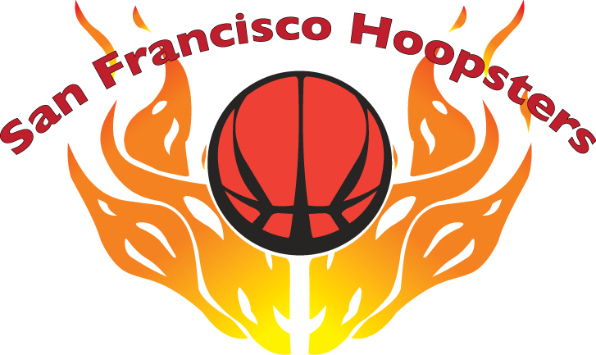

15th Annual Invitational Basketball Tournament
June 8-9, 2019

ROSTER FORM

ORGANIZATION: ___________________________________________________________________________

TEAM NAME: _______________________________________________________________________________

DIVISION: □9th □6th □3rd TEAM COLORS:____________________________________________

COACH: ________________________ MANAGER/CONTACT PERSON:__________________________

ADDRESS: __________________________________________ CITY/ZIP: _____________________________

TELEPHONE: HOME: __________________ WORK: _________________ CELL: ____________________

E-MAIL: ____________________________________

Please fill out roster in numerical order by jersey numbers. Roster changes must be received by May 1, 2019 and are subject to approval at the discretion of the tournament committee.

 | NAME OF PLAYER | JERSEY # | HEIGHT  (ft-in) | GRADE | BIRTHDATE  (m/d/yy)

1

2

3

4

5

6

7

8

9

10
Awards are limited to 10 players per team.

Roster forms are due by March 31, 2019.
Please send completed roster and check payable to “SF Hoopsters Organization” to:
Stephen Chan
50 Victoria Avenue, Suite 220
Millbrae, CA 94030

