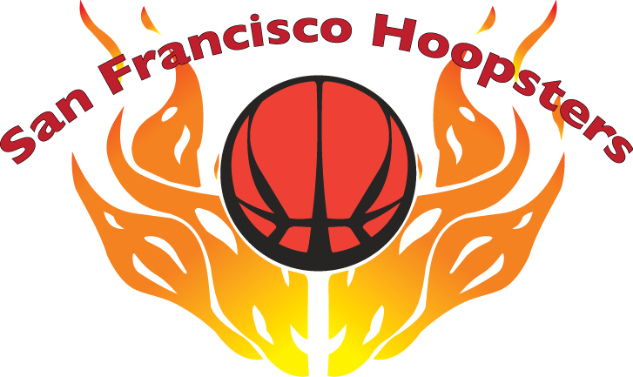

15th Annual Invitational Basketball Tournament
June 8-9, 2019

The San Francisco Hoopsters Organization cordially invites your team to participate in our 15th Annual Invitational Basketball Tournament. Please feel free to share this invitation with other divisions within your organization.

Tournament Dates: June 8-9, 2019

Location(s): San Francisco Bay Area

Divisions: 2-Day Tournament: Boys 9th grade
Boys 6th grade

1-Day Jamboree Boys 3rd grade

Entry Fee: Tournament - $425 per team
Jamboree - $275 per team
Check payable to: SF Hoopsters Organization

Mail Entry To: Stephen Chan
50 Victoria Avenue, Suite 220
Millbrae, CA 94030

Deadlines: March 31, 2019 Entry Fee and Team Roster Form
May 1, 2019 Roster Changes
June 8, 2019 Player Liability/Waiver Form
(due 15 min. before first game)

Please note that more invitations have been sent out than slots available in each division. The Tournament Committee will determine selection of participants and teams will be notified of acceptance in May.

Tournament rules and game schedule will be sent in subsequent mailings.

Each team is responsible for its own insurance coverage.

For more information and roster/waiver forms, please visit our website at www.sfhoopsters.org.

If you have any questions, please contact the Tournament Coordinator Stephen Chan at (650) 296-1167 or e-mail dkrusha@sbcglobal.net.

Thank you for your support and we look forward to your participation.

